Name: Quang Huynh Global 10-CRQ

**Document 1**

Whereas recognition of the inherent dignity and of the equal and inalienable rights of all members of the human family is the foundation of freedom, justice and peace in the world,

Whereas disregard and contempt for human rights have resulted in barbarous acts which have outraged the conscience of mankind, and the advent of a world in which human beings shall enjoy freedom of speech and belief and freedom from fear and want has been proclaimed as the highest aspiration of the common people,

Whereas it is essential, if man is not to be compelled to have recourse, as a last resort, to rebellion against tyranny and oppression, that human rights should be protected by the rule of law,

Whereas it is essential to promote the development of friendly relations between nations,

Whereas the peoples of the United Nations have in the Charter reaffirmed their faith in fundamental human rights, in the dignity and worth of the human person and in the equal rights of men and women and have determined to promote social progress and better standards of life in larger freedom,

Whereas Member States have pledged themselves to achieve, in co-operation with the United Nations, the promotion of universal respect for and observance of human rights and fundamental freedoms,

Whereas a common understanding of these rights and freedoms is of the greatest importance for the full realization of this pledge,

Now, Therefore THE GENERAL ASSEMBLY proclaims THIS UNIVERSAL DECLARATION OF HUMAN RIGHTS as a common standard of achievement for all peoples and all nations, to the end that every individual and every organ of society, keeping this Declaration constantly in mind, shall strive by teaching and education to promote respect for these rights and freedoms and by progressive measures, national and international, to secure their universal and effective recognition and observance, both among the peoples of Member States themselves and among the peoples of territories under their jurisdiction.

Source: **The Universal Declaration of Human Rights**, United Nations, 1948

**Historical Context-** the historical circumstances surrounding this event/idea/ historical development.

Using document 1, explain the historical circumstances that led to the historical development in the document.

In document one, the Universal Declaration of Human Rights is made, which allows for the basic rights of everyone. Conflicts between individuals would cause for this declaration to be created. Acts such as slavery, where the slaves were treated very poorly, would be a factor to this declaration. Furthermore, this declaration was made in hopes of events like the Holocaust to not ever happen again.

**Document 2**

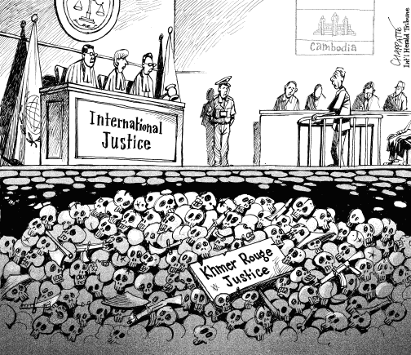

**Source:** www.thethinglink.com

Using document 2, identify and explain the cartoonist’s point of view shown in this cartoon.

The cartoonist’s point of view of the cartoonist shows that the International Justice completely failed the people in Cambodia. The cartoonist was not pleased with the results of this court case. Since the events that took place in Cambodia didn’t classify as genocide since it couldn’t be proven by the United Nations.

**Document 1 Document 2**

Whereas recognition of the inherent dignity and of the equal and inalienable rights of all members of the human family is the foundation of freedom, justice and peace in the world,

Whereas disregard and contempt for human rights have resulted in barbarous acts which have outraged the conscience of mankind, and the advent of a world in which human beings shall enjoy freedom of speech and belief and freedom from fear and want has been proclaimed as the highest aspiration of the common people,

Whereas it is essential, if man is not to be compelled to have recourse, as a last resort, to rebellion against tyranny and oppression, that human rights should be protected by the rule of law,

Whereas it is essential to promote the development of friendly relations between nations,

Whereas the peoples of the United Nations have in the Charter reaffirmed their faith in fundamental human rights, in the dignity and worth of the human person and in the equal rights of men and women and have determined to promote social progress and better standards of life in larger freedom,

Whereas Member States have pledged themselves to achieve, in co-operation with the United Nations, the promotion of universal respect for and observance of human rights and fundamental freedoms,

Whereas a common understanding of these rights and freedoms is of the greatest importance for the full realization of this pledge,

Now, Therefore THE GENERAL ASSEMBLY proclaims THIS UNIVERSAL DECLARATION OF HUMAN RIGHTS as a common standard of achievement for all peoples and all nations, to the end that every individual and every organ of society, keeping this Declaration constantly in mind, shall strive by teaching and education to promote respect for these rights and freedoms and by progressive measures, national and international, to secure their universal and effective recognition and observance, both among the peoples of Member States themselves and among the peoples of territories under their jurisdiction.



**Causation-** Identify and explain a cause and effect relationship between the events or ideas found in these documents.

Identify ***and*** explain a ***cause-and-effect*** relationship associated with the events, ideas, or historical developments in documents 1 and 2. Be sure to use evidence from ***both*** documents 1 and 2 in your response.

I believe events such as in document 2 would cause document 1. Atrocious events such as genocide causes international policies to be made to prevent things like mass genocide. Although document one occurred before document 2, changes can still be made to the Universal Declaration of Human Rights. So, after the Cambodian Genocide, changes would have to been made to the Universal Declaration of Human Rights to stop any further barbaric events in history. Furthermore, more policies and acts would be made which brought the perpetrators of the Khmer Rouge’s crimes to trial, which allowed research to be done to avert anymore historical disasters from happening.